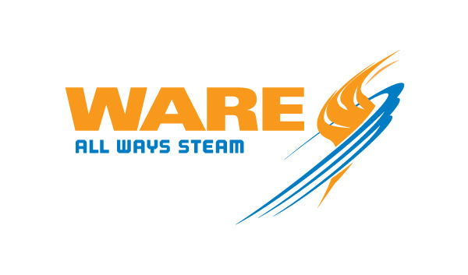
FOR IMMEDIATE RELEASE
6-15-2024
For more information, please contact Steven.Taylor@wareinc.com

WARE goes high capacity with a 200,000 pph mobile deaerator system, allowing even the largest rental boilers to operate with properly treated feedwater at all times.

(Louisville, KY)

As boilers operate, they convert water to steam. This means the level of available water in the boiler will drop over time. This steady water loss, therefore, necessitates the addition of new “makeup” water into the boiler’s pressure vessel. For high-capacity boilers that convert a lot of water into steam, replacing that lost water with water that’s been properly treated for boiler usage has been a difficult task in mobile boiler systems. But that’s no longer the case, as WARE has constructed a mobile water treatment and deaeration system that can supply steam plants that generate up to 200,000 pounds of steam per hour.
While other manufacturers offer mobile deaerators that can supply a 200,000 pph boiler with deaerated water, the challenge of proper softening at that scale was once difficult to overcome. Now, WARE is the first to integrate a water softener and deaeration system into one single, portable unit that can be used to supply high-output boilers anywhere the demand arises, with up to ten minutes worth of water storage for periods of high demand. What’s more, the water softener included in the system is designed for 100% makeup, negating the need for an additional piece of equipment or an additional water treatment trailer. WARE has taken that all into account, and can now include the water softener in the mobile package.

LOST WATER
Even the most modern and efficient boilers require makeup water. Some is lost to evaporation, some is lost in the end work process, and still more water is lost to the regular “blowdowns” that boiler operators perform to vent away the sediment, minerals, and other solids that collect on the bottom of the pressure vessel.
If the sediment, minerals, and other solids are allowed to collect, they will prove harmful to the boiler in two primary ways. First, they will solidify into “scale”, which will form a hard layer inside the pressure vessel that impedes heat transfer. If scale is allowed to develop, the boiler will have to use more fuel to transfer the same amount of heat which will diminish operating efficiency and increase fuel costs.
The second reason these impurities must be removed is because they react with the heat and oxygen inside the boiler to cause corrosion. If left unchecked, this corrosion will eat away at the pressure vessel walls and the other internal components of the boiler, reducing its useful life.

HIGH DEMAND
Another important function of makeup water has to do with demand management. If the need for steam suddenly increases, the boiler will have to put more steam into circulation. This means the water level in the pressure vessel will drop, necessitating the addition of makeup water. If the makeup water isn’t added, the low water level switches will shut the boiler down for safety and steam to the plant will cease. This is critical, because unexpected shutdowns prove detrimental to the process that the steam is supplying.

PROPER TREATMENT
For optimal operation, the water inside a boiler must be softened before use. This process is done by an industrial water softener that uses ions suspended on a resin membrane to strip away the harmful calcium, iron, and magnesium ions that are found in “hard” water. By removing these molecules, the water becomes “softer”, and is therefore less likely to cause scale and corrosion.

DEAERATION
Oxygen is extremely harmful to the internal workings of an industrial boiler. Therefore, removing it is key to safe, efficient operation. That’s where the process of deaeration comes in. By separating out the excess oxygen before the condensate enters the boiler as makeup water, the boiler’s life can be extended, and its efficiency preserved. Depending on the type of deaerator, the oxygen can be removed in one of two ways. First, by spraying the condensate into a fine mist and allowing the oxygen to separate. The second method involves passing the condensate over a series of trays that allow the excess oxygen to separate from the water.
Both types of deaerators use heat from steam to accelerate the oxygen removal process. Not only does heating the water help deaerate it, but it also helps pre-warm the makeup water before it is introduced back into the pressure vessel. Preheating helps reduce a phenomenon known as “thermal shock”, which occurs when the temperature between the pressure vessel water and the makeup water is too great. If the makeup water is at too low a temperature, it will not only cause the boiler to have to work harder to convert the water into steam, but it can actually damage the boiler’s pressure vessel and other internal components.

DEMAND VERSUS SUPPLY
The processes of water softening and deaeration are not instantaneous. Because of this, the supply of softened and deaerated water can be depleted over time. This is especially true of high-capacity boilers that require a substantial amount of treated feedwater. If the supply of softened and deaerated water runs out, the boiler still needs to be supplied with water. This will unfortunately necessitate the addition of untreated, oxygen-rich hard water, which will increase the likelihood of scale and corrosion developing inside the boiler.

BETTER OPERATION AT EVERY LEVEL
By introducing mobile water treatment equipment with such a high output, WARE has ensured that boilers of all sizes can have sufficient makeup water without sacrificing performance or longevity. It’s just one more way WARE continues to lead the field in keeping customers supplied with the equipment they need to maintain production and avoid costly downtime.

